**Biology, Castle View High School  
Dr. Jason R Mayberry**

**Study Guide: Atoms and Ions**

**Vocabulary Summary**

1. Atom
2. Simple Molecule
3. Macromolecule
4. Cell
5. Life
6. Proton
7. Neutron
8. Electron
9. Electron Cloud
10. Nucleus
11. Periodic Table
12. Atomic Number
13. Atomic Symbol
14. Electron Cloud Energy Shell
15. Electron Configuration
16. Valence Electrons
17. Lewis Dot Structure
18. Octet Rule
19. Noble Gasses
20. Ion
21. Cation
22. Anion

**Notes/Conceptual Questions**

1. Explain why and how chemistry is foundational to the study of biology, including the social-political-ethical issues we will address.
2. Describe the relationship between Atoms and Ions, Simple Molecules, Macromolecules, and Cells.

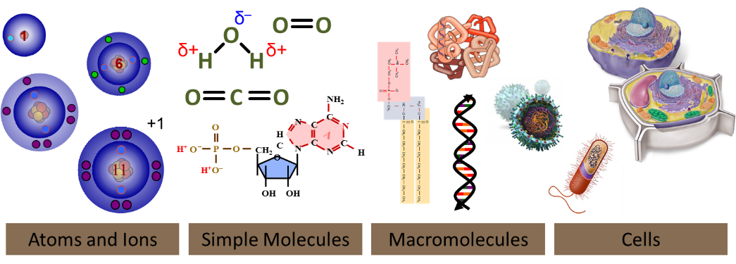

1. Identify and describe the characteristics of the parts of an atom.

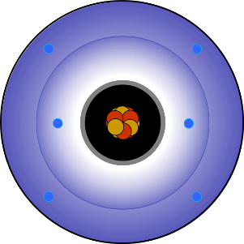

1. Which part of an atom determines its identity?
2. Which part of atom is directly responsible for interacting with other atoms?
3. Describe the characteristics of the electron cloud.

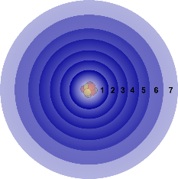

1. Define electron configuration, and Valence electrons; explain how they influence an atoms behavior (i.e. interactions with other atoms)

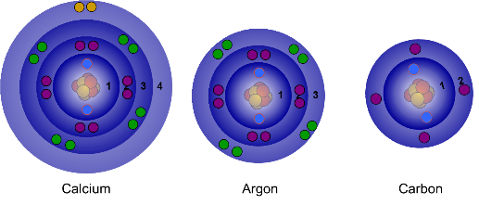

1. Use the periodic table to determine the number of valence electrons in a neutral atom?



1. Draw a Lewis Dot structure for any atom.
2. What happens when atoms gain or lose electrons? (i.e. how can you determine the charge on an atom/ion”?)
3. What are the two “desires” (*i.e.*, physical parameters that result in atoms being stable) *(which ultimately lead to them forming molecules)*?
4. Indicate on the periodic table which atoms will form cations, which will form anions, and which will not form ions. Explain why.



1. Draw examples of Lewis Dot structure for +2 cations, +1 cations, -1 anions and -2 anions.